St Andrew’s Church
Orford with Longford
in the Diocese of Liverpool
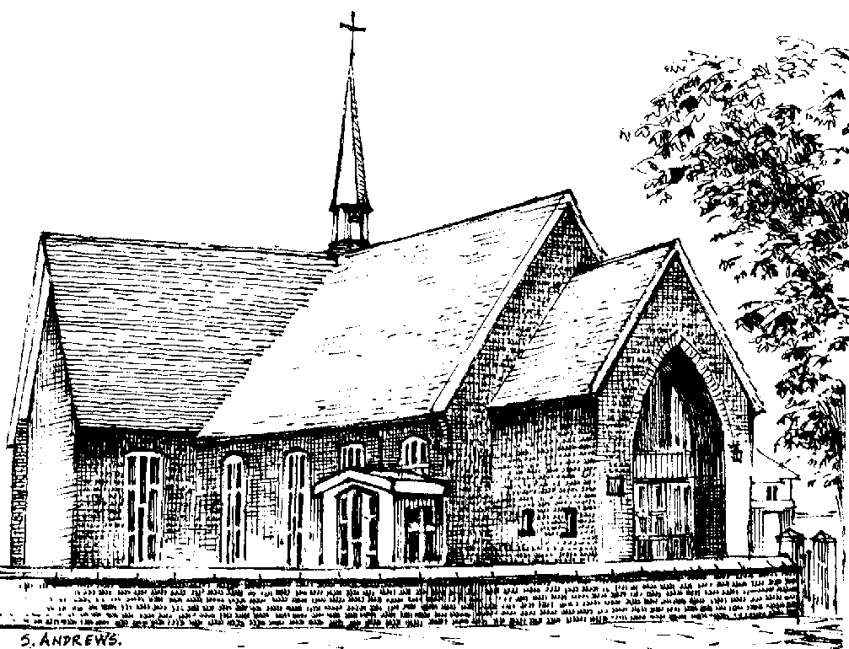

Clifford Hall

27th July 1926 – 20th May 2013

Friday 31st May 2013

Order of Service

Please stand as the family enters church. Please sit once the family are seated.

Introduction

All: Merciful Father, hear our prayers and comfort us; renew our trust in your Son, whom you raised from the dead; strengthen our faith that all who have died in the love of Christ will share in his resurrection; who lives and reigns with you, in the unity of the Holy Spirit, one God, now and for ever. Amen

Hymn: “The Lord’s my shepherd”

The Lord's my Shepherd, I'll not want;
he makes me down to lie -
in pastures green; he leadeth me -
the quiet waters by.

My soul he doth restore again,
and me to walk doth make -
within the paths of righteousness,
e'en for his own name's sake.

Yea, though I walk through death's dark vale,
yet will I fear no ill;
for thou art with me, and thy rod -
and staff me comfort still.

My table thou hast furnished
in presence of my foes;
my head thou dost with oil anoint ,
and my cup overflows.

Goodness and mercy all my life
shall surely follow me;
and in God's house, for evermore
my dwelling place shall be.
The Ministry of the Word

The Scriptural Reading (Revelation 21. 1-7)

The Address including a tribute by Michael on behalf of the family

The Prayers:

Each section concludes:
Lord, in your mercy
All: hear our prayer.

After the final section:
God of mercy, entrusting into your hands all that you have made and rejoicing in our communion with all your faithful people, we make our prayers through Jesus Christ our Saviour. Amen.

The Lord’s Prayer

All: Our Father, who art in heaven, hallowed be thy name; thy kingdom come; thy will be done; on earth as it is in heaven. Give us this day our daily bread. And forgive us our trespasses, as we forgive those who trespass against us. And lead us not into temptation; but deliver us from evil. For thine is the kingdom, the power and the glory, for ever and ever. Amen

Hymn: “Abide with me”

Abide with me; fast falls the eventide:
the darkness deepens; Lord, with me abide:
when other helpers fail, and comforts flee,
help of the helpless, O abide with me.

Swift to its close ebbs out life's little day;
earth's joys grow dim, its glories pass away;
change and decay in all around I see:
O thou who changest not, abide with me.

I need thy presence every passing hour;
what but thy grace can foil the tempter's power?
Who like thyself my guide and stay can be?
Through cloud and sunshine, Lord, abide with me.

I fear no foe with thee at hand to bless;
ills have no weight, and tears no bitterness,
Where is death's sting? Where, grave, thy victory?
I triumph still, if thou abide with me.

Hold thou thy cross before my closing eyes;
shine through the gloom, and point me to the skies:
heaven's morning breaks, and earth's vain shadows flee;
in life, in death, O Lord, abide with me.

Commendation and Farewell

All: Heavenly Father, in your Son Jesus Christ you have given us a true faith and a sure hope. Strengthen this faith and hope in us all our days, that we may live as those who believe in the communion of saints, the forgiveness of sins and the resurrection to eternal life; through Jesus Christ our Lord. Amen.

Acknowledgement: Common Worship: Pastoral Services, material from which is included in this service, is copyright © The Archbishops’ Council (2000) Hymns reproduced under CCLI licence number 2101652

